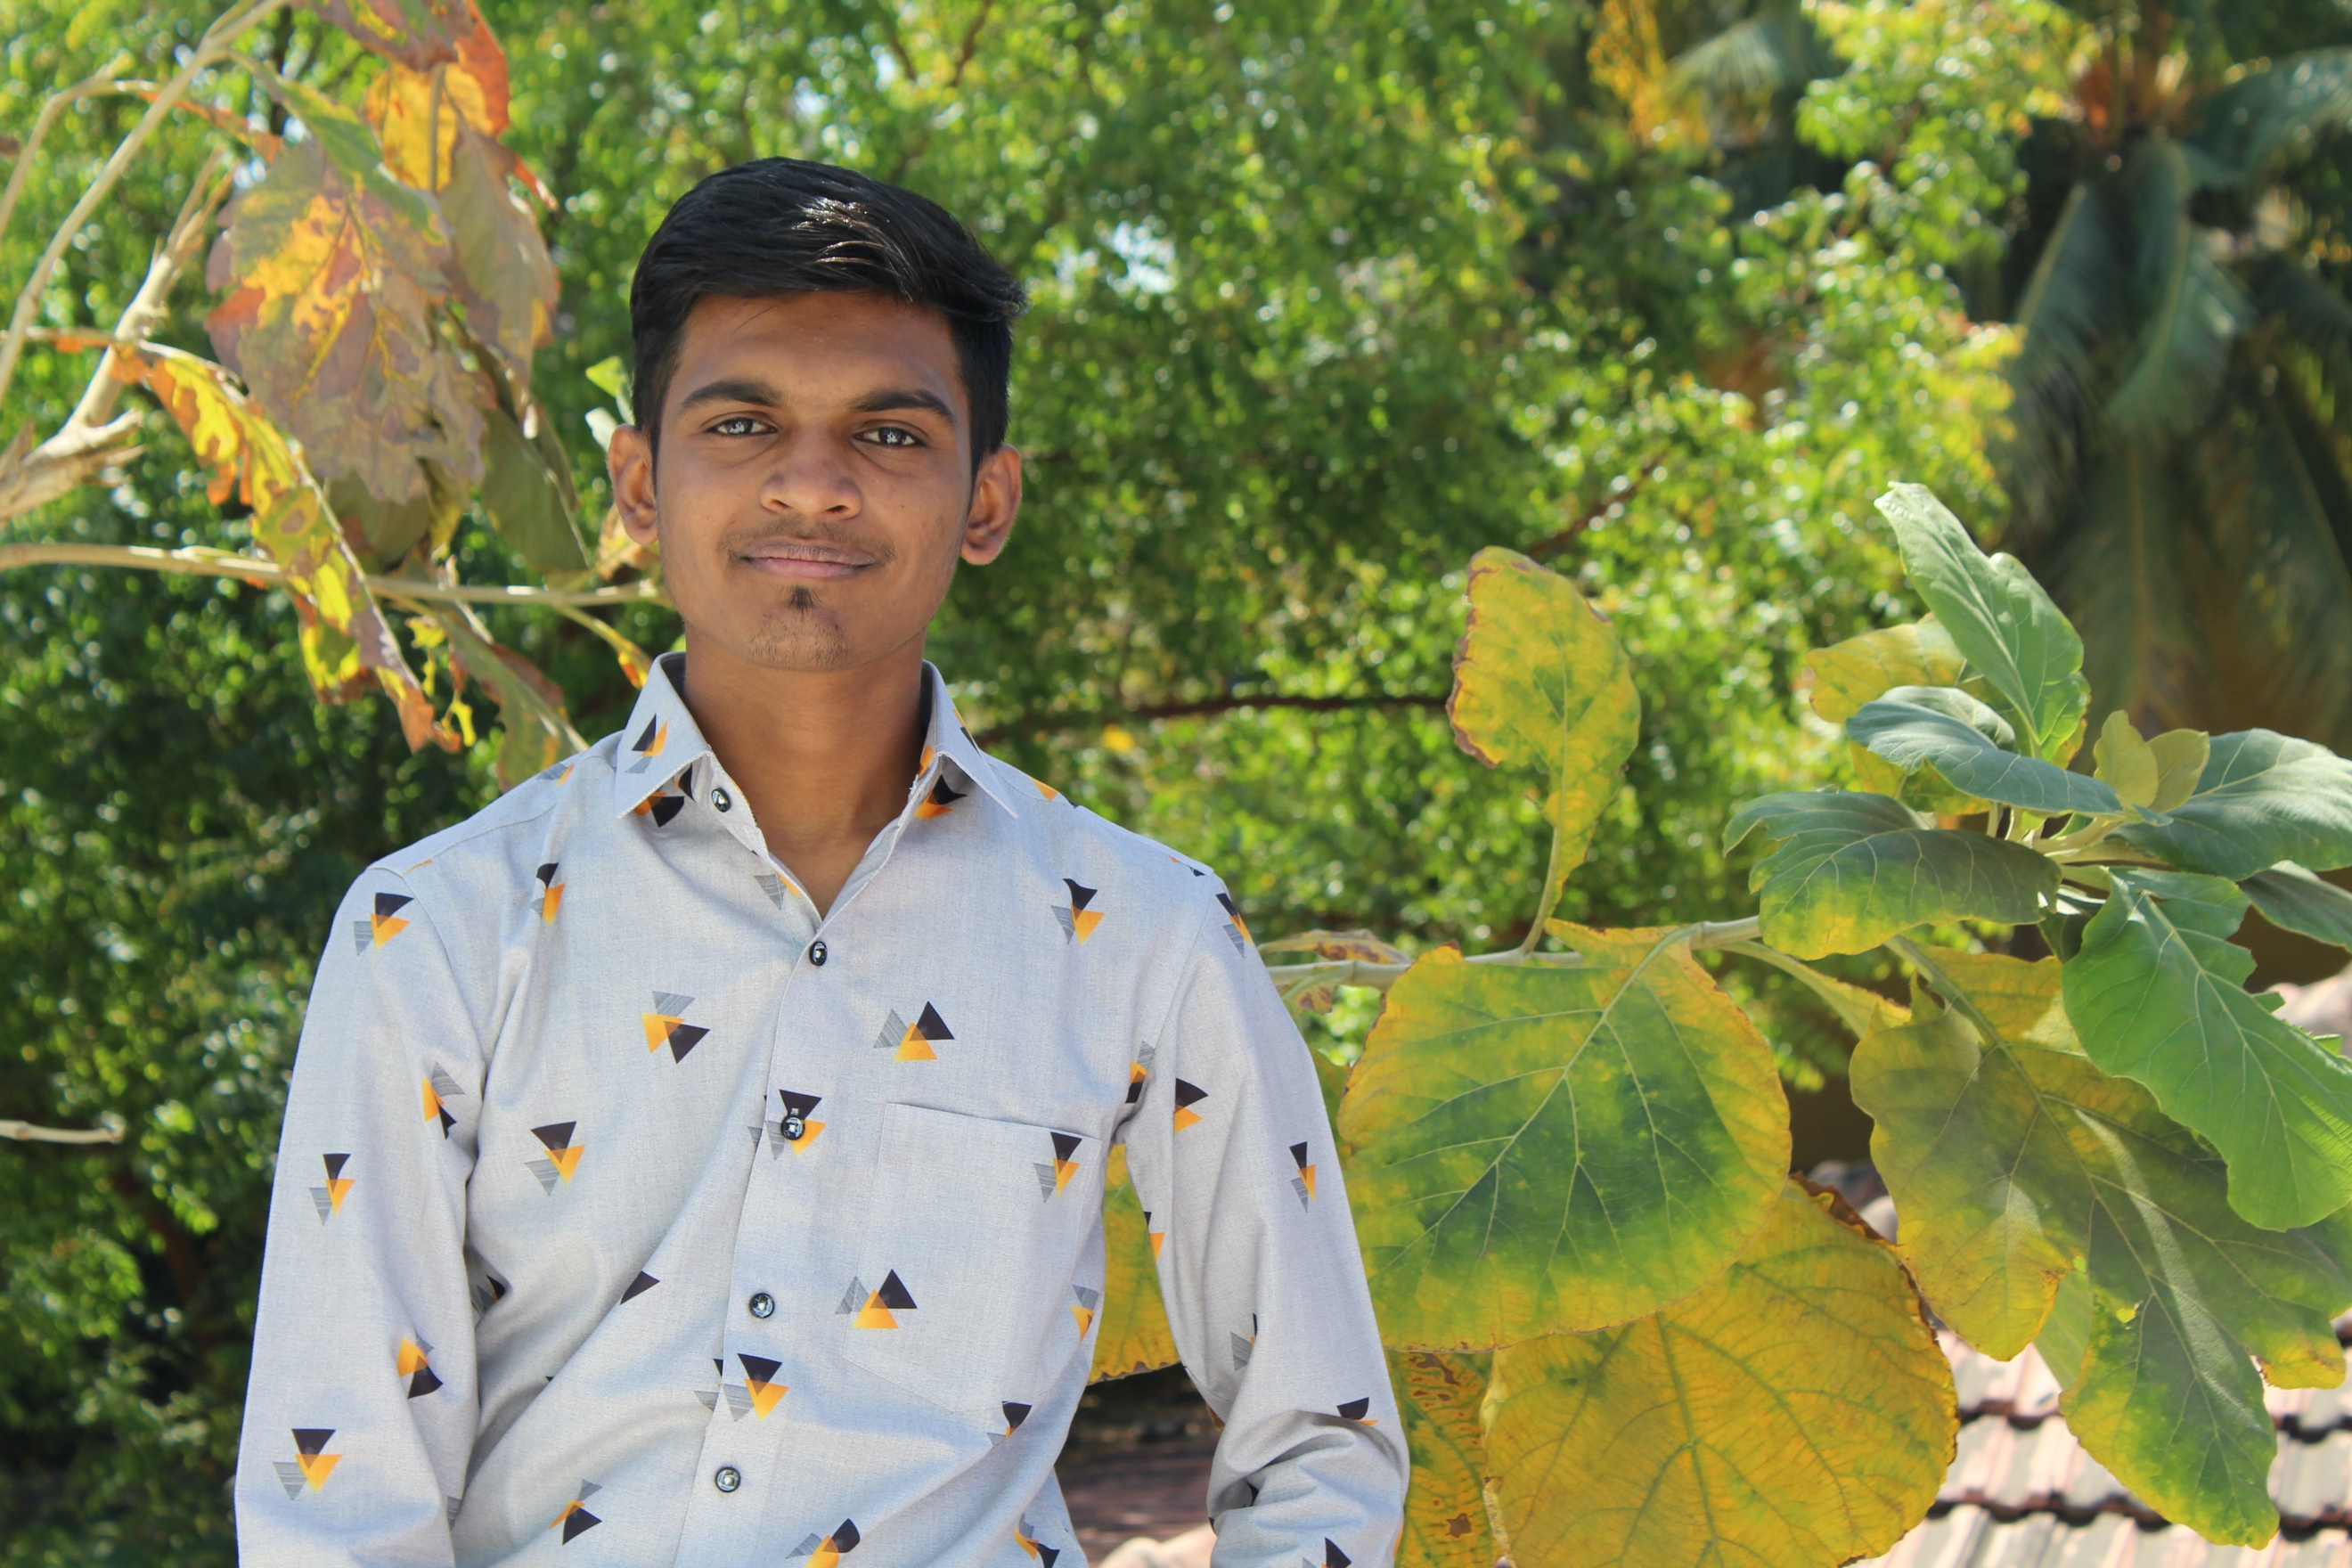

**Address:**  At. Po. Paria, Ta. Olpad,

Dist. Surat-394130,

Gujarat.

**Mobile No:**  +91 99242 09820

**Email Address:** priyanklad52@gmail.com

**Priyank Lad**



**Objective**

I want to see myself as an active contributor in organization and thereby enhancing my knowledge and personality to take a challenging and high-performance oriented role in the field of computer engineering.



**Education**

**Secondary School Certificate with GSEB Board Graduated, 2014**

P.P. Savani Chaitanya Vidhya Sankul 75.17%

Surat, Gujarat

**Higher Secondary School Certificate with GSEB Board Graduated, 2016**

Shree Vashishtha Vidhyalaya 55.20%

Surat, Gujarat

**B. Sc. Information Technology Graduated, 2018**

Uka Tarsadia University 6.16 CGPA

Surat, Gujarat

**M.Sc. Computer Science Pursuing, 2020**

MIT World Peace University

Pune, Maharashtra



**Projects**

* **Point of Sale System**
* Language of Implementation: Asp.net
* Live Project as per Company requirement
* Software for Retail Shop
* **Dairy Management System**
* Language of Implementation: PHP
* Live Project as per Client requirement
* **Sentiment Analysis on Twitter’s Tweet**
* Language of Implementation: R Programing
* Plot the Graph based on Analysis from Tweets



**Certification**

* Student Talent Search Test held by Gujarat Secondary and Higher Secondary Education Board Gandhinagar.
* Participated in NCAT Examination.
* National Services Scheme Certificate at Uka Tarsadia University Bardoli, Surat.
* Certification of “Java for Android” by Vanderbilt University on Coursera.



**Skills & Abilities**

**KNOWLEDGE OF PROGRAMMING LANGUAGES, DATABASE AND TOOLS**

* **Languages**: C, C++, Java, Python, C#, F#, ASP.Net, Android, R programing, AngularJS.
* **Platforms**: Windows XP/ 7/8/8.1/10, Mac, Linux.
* **Web Design**: HTML, CSS, Bootstrap, JavaScript, Ajax.
* **Database**: SQL 2008 R2, My SQL.
* **Tools:** Ms. Visual Studio, Android Studio, Net Beans, RStudio, Xcode, PyCharm

**TECHNICAL SKILLS**

* I have experience in working with different operating system and platforms namely Mac, Windows, UNIX.

**Personal Abilities**

* Ability to make sound decisions.
* Good communication and organizing skills.
* Fast learning.
* Team work.
* Pragmatic.



**Personal Details**

* **Date of Birth:** 5th February1999
* **Gender:** Male
* **Father's Name:** Pankajbhai Lad
* **Mother's Name:** Sangitaben Lad
* **Nationality:** Indian
* **Hobbies:**  Music, Reading, Travelling, Volleyball, Basketball, Photo & Video Editing
* **Languages Known:** English, Hindi, Gujarati

**Declaration**

I, Priyank Lad, hereby declare that the information contained herein is true and correct to the best of my knowledge and belief.

__________________________  
PRIYANK LAD